GENERIC PROTOCOL FOR MANAGING OBSTETRIC / GYNAECOLOGICAL EMERGENCIES IN COVID-19 POSITIVE PATIENT
This protocol is based on PPE advice from Public Health England, simulation and emerging clinical experience so is subject to change.
KEY PRINCIPLES
- RAPID, EFFECTIVE COMMUNICATION IS ESSENTIAL such as using radio communication instead of phones and bleeps to minimise the delays introduced by the infection control, PPE requirements and increased cognitive load that will be borne by staff caring for COVID-19 patients.

- EFFECTIVE USE OF PERSONAL PROTECTIVE EQUIPMENT IS THE PRIORITY. Whilst the instinct of staff may be to rush into an emergency disregarding their own safety, putting on Personal Protective equipment should be prioritised. Staff who become infected due to ineffective use of PPE will put themselves at personal risk. This will also have knock-on effects on the safety of the overall system if large numbers of staff are unable to attend work.

- MANAGEMENT DELAYS ARE HIGHLY LIKELY in COVID-19 positive patients due to the need for staff to put on Personal Protective Equipment. Even in the context of emergencies (including cardiac arrest), staff are not to approach patients, commence management or enter isolation area without PPE which has been checked by a buddy. Removing PPE should also be done with a buddy.
CONTEXT
- Midwives/nurses in room with COVID-19 positive patient. Midwives/nurses have radio communication with wider team (walkie talkies). Walkie talkies held by Band 7 Midwife or equivalent, Senior Obs&/Gynae Doctor (Cons / SpR) +/- Anaesthetist. One extra walkie talkie to remain outside the room at all times.
- PPE donning station immediately outside isolation room with standard PPE PLUS sterile theatre gloves for emergencies to aid speed of donning and provide protection if staff doing manoeuvres (standard nitrile gloves not sufficient for this). CHOICE OF PPE: The RCOG recommends GLOVES, APRON & GOWN, FLUID RESISTANT SURGICAL MASK & VISOR for staff attending a woman in labour. When attending an emergency where there is a risk of GA (Cat1 CS without regional anaesthesia, PPH) or needing to do CPR then a Filtering Face Piece Level 3 (FFP3) mask should also be used.
- Doffing station with infectious waste bin and alcohol gel inside room. 2nd doffing station with alcohol gel and infection waste bin outside room (for mask removal).
- PPH, Eclampsia medications & emergency delivery equipment should be available in isolation room/bay.
DRILL
Emergency identified

COMMUNICATING EMERGENCY

Midwife pulls emergency buzzer

Midwife radios to team ‘Obstetric Emergency in COVID bay, PPH’ (or Shoulder dystocia etc) | Rapid communication and contextual information conveyed to team to minimise delay and allow appropriate team members to attend.
Team respond ‘on our way’ | Team in room aware their request has been received – very important that they are aware help is coming considering the likely delay that will occur during donning of PPE.
Midwifes commence emergency management

DONNING PPE

Ideally minimum of three people attend  All three don PPE but focus on getting most senior team member ready first, followed by 2 other team members | In simulation, focussing on most senior team member resulted in them getting into room much faster (2 mins or less) followed by other team members (3-4mins)
Most senior clinician enters room | In simulation, the instinct is to send in members as they are ready, this may lead to the last member not being checked which will increase their risk of exposure.
Remaining members check PPE and enter together.
Team members NOT to enter room until PPE checked properly by buddy – DO NOT leave anyone to complete their PPE alone.
MANAGEMENT OF EMERGENCY

Team in room complete management of patient as per standard emergency protocols. Ideally, necessary equipment should be available inside room. | Having equipment in room may reduce delays associated with PPE donning if further equipment needed. Also reduces risks of exposure.
If transfer to theatre required – see transfer protocol

REMOVING (DOFFING) PPE | After the adrenaline rush and emotion involved in managing an emergency, staff must take special attention when removing their PPE. One of the highest risks of exposure occurs when PPE is removed, especially the visor.
Staff exiting the room, remove gloves and gown inside the room keeping mask and visor in place but applying alcohol gel to hands.
Remove mask and visor outside the room at doffing station and apply alcohol gel to hands. A buddy, standing at 2m distance should observe PPE removal to ensure it is done correctly.
Exiting team should also wash hands at the nearest sink.
Team should also consider whether cleaning of footwear or change of clothes required depending on what interventions they have had to perform to manage emergency. | Obs / Gynae procedures are some of the highest risk in terms of exposure to blood / faeces and bodily fluids. There is evidence that COVID-19 can live in blood / faeces (Whether this increases the transmission risk is unclear).

SUMMARY
Applying PPE properly in teams requires practice. Adopting new ways of managing emergencies in which team members take time to prioritise who goes in the room first and pause to apply and check PPE may take time. Practice and simulation is very important so that teams are as prepared as possible when COVID-19 positive patients arrive in their respective units.

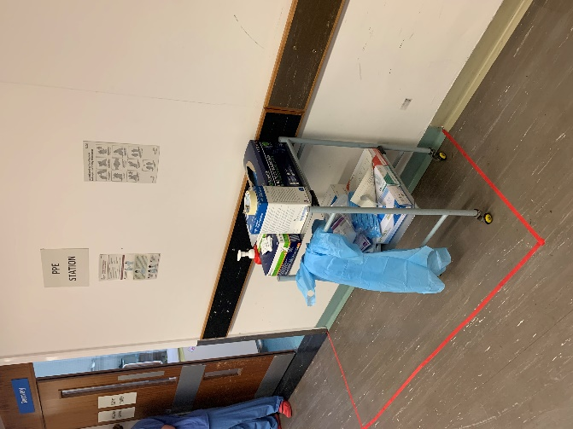
VISUAL SUMMARY

ENSURE ADEQUATE PPE EASILY AVAILBALE OUTSIDE ROOM FOR EMERGENCIES INCLUDING STERILE SURGICAL GLOVES

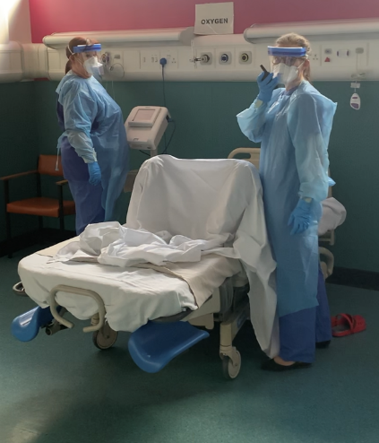

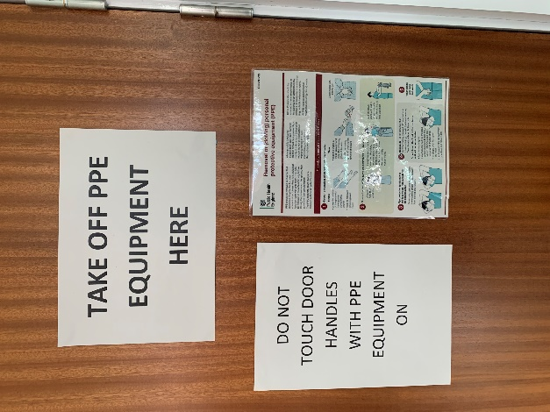
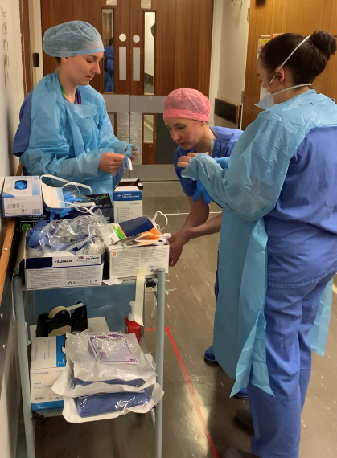
PRIORITISE PUTTING ON SAFE PPE FOR THE WHOLE TEAM. ADAPT BUDDYING SO THAT SENIOR TEAM MEMBERS ENTER ROOM QUICKLY
ENSURE THAT PPE IS TAKEN OFF SAFELY AND THAT 2 DOFFING STATIONS (ONE INSIDE, ONE OUTSIDE) ARE CLEARLY MARKED AND ACCESSIBLE
USE METHODS OF RAPID COMMUNICATION (E.G. WALKIE TALKIES) ALONGSIDE USUAL ALERTS SUCH AS EMERGENCY BUZZER

